ID.no. New subsidiary in Hong Kong 5.8.2015 , changed:
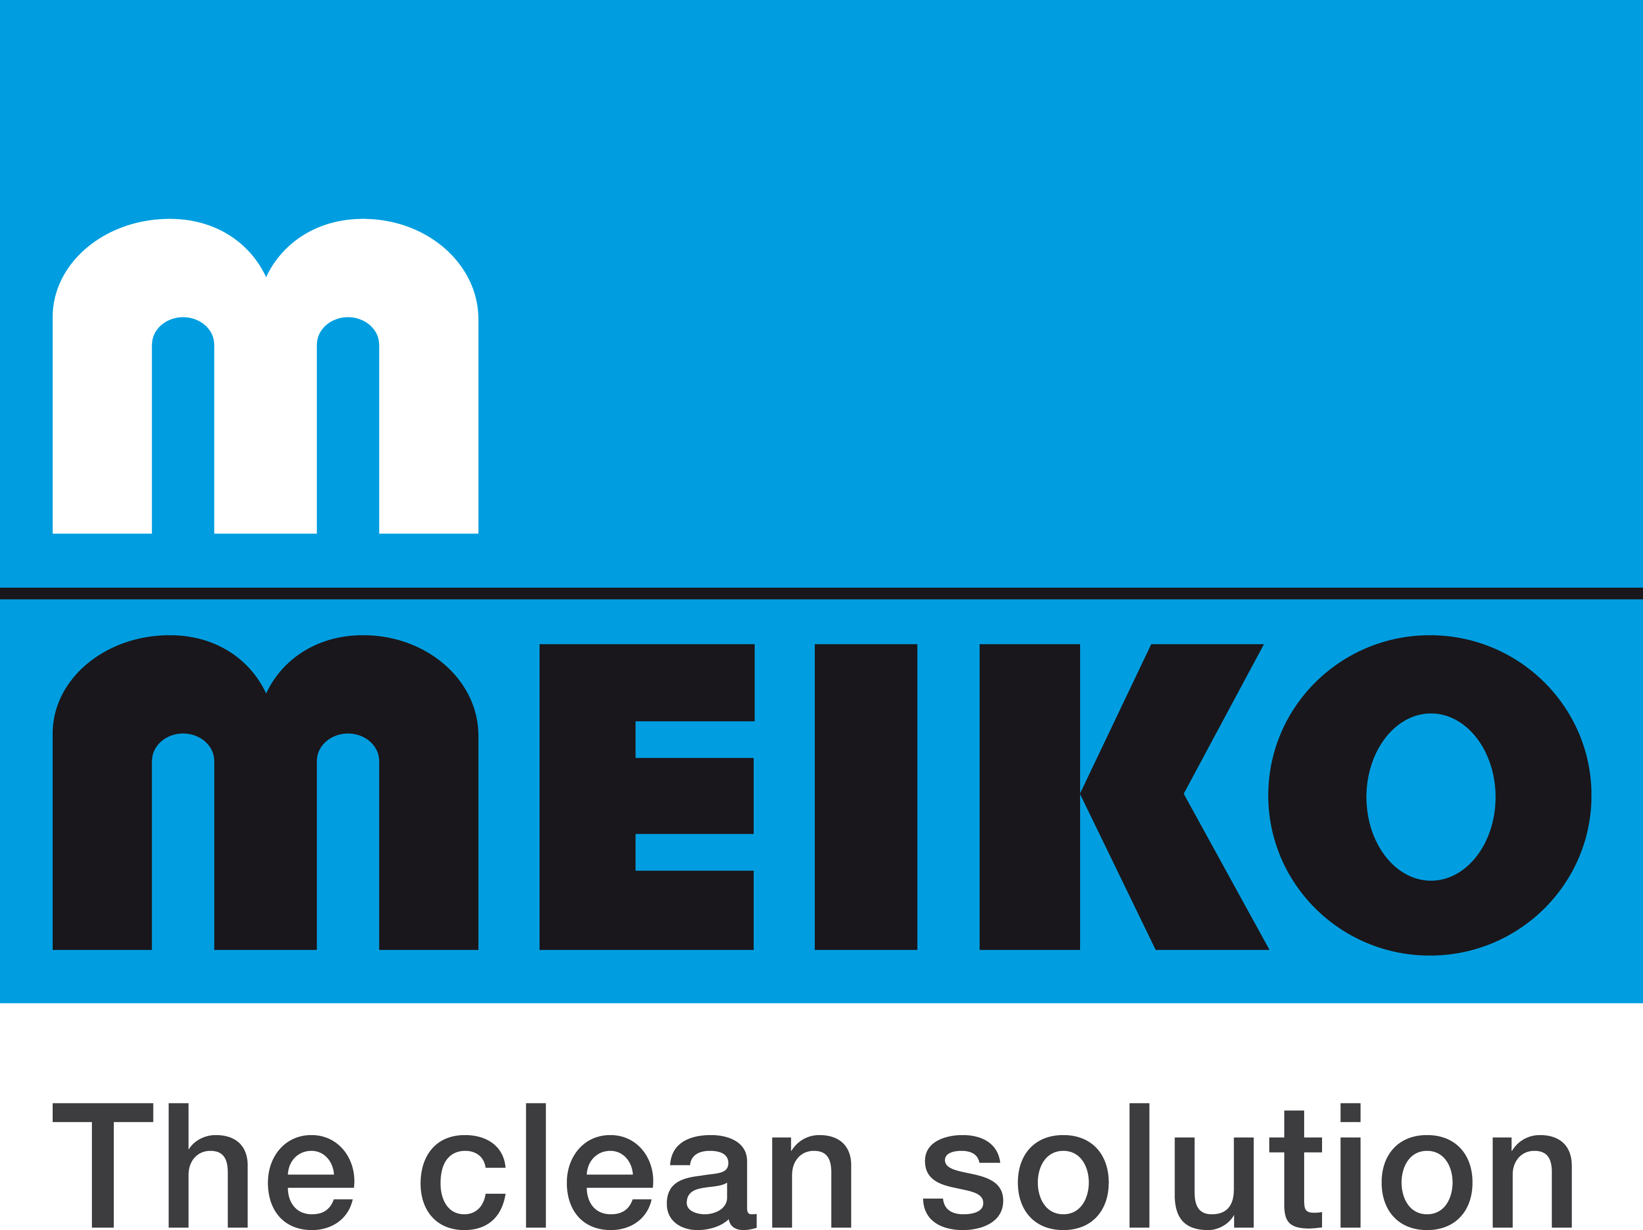
Meiko boosts competitiveness
with subsidiary in Hong Kong

The Offenburg, Germany-based dishwashing technology specialist Meiko has opened a new subsidiary in Hong Kong as part of its strategy to safeguard its competitiveness in the market. Meiko Clean Solutions Hong Kong Ltd. – which opened for business in Kowloon Bay, Hong Kong in July 2015 – marks another step in the German company's worldwide growth.

"Opening an office in Hong Kong further expands our remarkably successful operations in the strategic Asia-Pacific growth region," says Meiko managing director Dr.-Ing. Stefan Scheringer, "and it also provides us with a base for serving customers in Macao and Taiwan." Just last year the company boosted its presence in Malaysia by opening a subsidiary in Kuala Lumpur. The manufacturer of dishwashing, cleaning and disinfection technology also has offices in Zhongshan, China, which opened in 1997, as well as in Bangalore, India and in the Australian city of Sydney.

The new Meiko subsidiary in Hong Kong is headed by general manager sales and service Louis Lam (37), who has been working in the industry for nine years and has built up excellent connections and expertise in the field. He already has four people working for him, and two additional staff members will be joining his team before the end of this year. "This commitment to the region is not only designed to promote our sales activities, but also to ensure that our customers in these countries receive the outstanding levels of service Meiko is renowned for. The Meiko name stands for clean solutions and represents a promise to our customers," says Scheringer. As well as numerous restaurants and hotels, Meiko's customers in the Hong Kong region include airline catering companies, staff restaurants, cafeterias, hospitals and other catering facilities. Some 4,500 authorised service technicians worldwide are on hand to safeguard the availability of Meiko machines in the unlikely event of a breakdown. Meiko offers sustainable solutions in the fields of dishwashing, cleaning and disinfection, providing technology which is designed to keep pace with the accelerated logistics and material flow processes found in large-scale foodservice operations such as airline catering.

"We're proud that we can fully embrace a policy of thinking globally and acting locally by drawing on the technology from our headquarters in Offenburg and supplementary products from our Chinese subsidiary," says Scheringer. "Meiko is determined to spread the exceptional quality of its German engineering worldwide, offering its customers both entry-level and premium-class models."

